Marmara Üniversitesi Mühendislik Fakültesi
Elektrik-Elektronik Mühendisliği

Mehmet Ali Kamalak
150720062

Laboratory Manual

EE 3011

Electronics I

Experiment (1) Introduction to LTspice 1

Spring 2024

Objectives

Experiment (1) Introduction to LTspice

- To simulate simple passive circuits using DC and Transient analysis.
- To be able to generate LTspice results using plots for various circuit variables.

Pre-lab Work
Before starting this experiment, you need to study the document “Introduction to LTspice IV with Examples”, by Nicholas Lombardo, Linear Technology, 2015.

Circuits

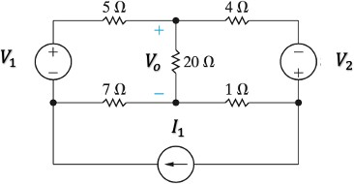
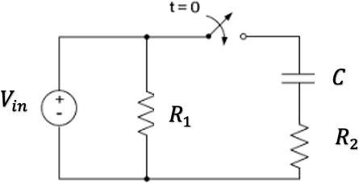

Figure 1: A DC circuit. Figure 2: Transient circuit.

Page2

Procedure
Part (1): DC Analysis.
- Connect the circuit in figure 1. Use the voltage and current sources values given by the lab instructor.
- Using simulation, find the DC voltages and currents for all resistors. Record results in table 1.
- Now make source 𝑉₁ as a variable voltage source and use the DC Sweep function to produce the transfer function curve 𝑉_{𝑜} versus 𝑉₁.

Part (2): Transient Analysis.
- Connect the circuit in figure 2. Use the circuit elements values given by the lab instructor. Set
𝑉_{i𝑛} as a periodic rectangular signal with frequency 𝑓 and maximum amplitude 𝑉_{𝑚𝑎𝑥}. The switch is initially closed.
- Simulate the steady-state response of the circuit. Produce the steady-state voltage waveforms (versus time) across the capacitor 𝐶 and the resistor ₍. Put these curves together with the 𝑉_{i𝑛} curve on the same plot.
- Now, as the switch is opened at 𝑡=0, simulate the circuit using the Transient analysis function and generate the voltage waveform (versus time) across the capacitor 𝐶 and the resistor 𝑅₂.

Page3
Put these curves together with the 𝑉_{i𝑛} curve on the same plot. Also observe the waveform of the current through ₍. From the curves, find the time constant of the circuit.
- Change the value of 𝑓 and repeat step 3.

Results and Analysis

Part (1): DC Analysis.

Table 1. DC Simulations in Part (1).

𝑉₁ =1V 𝑉₂ =2V 𝐼₁ =1A | Simulation | Calculation | % Difference
Voltage across 1 Ω resistor | -360.01 mV | 359.05 mV | %0.26
Current through 1 Ω resistor | -360.01 mA | 359.05 V | %0.26
Voltage across 4 Ω resistor | -2.56 V | 2.56 V | %0
Current through 4 Ω resistor | -640 mA | 635 mA | %0.7
Voltage across 5 Ω resistor | -3.250 V | 3.25 V | %0
Current through 5 Ω resistor | -650 mA | 648 mA | %0.3
Voltage across 7 Ω resistor | -2.45 V | 2.44 V | %0.4
Current through 7 Ω resistor | -350 mA | 348 mA | %0.5
Voltage across 20 Ω resistor | -200 mV | 199.5 mV | %0.25
Current through 20 Ω resistor | -10 mA | 10 mA | %0

1. Comment on the difference between simulation and theoretical values in table 1.

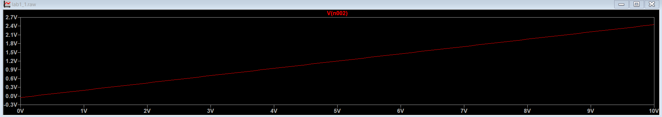
The simulation and theoretical calculation results in Table 1 are very close to each other, with percentage differences mostly below 1%. This indicates that the simulation accurately represents the theoretical expectations. The observed deviations are negligibly small. In general, the agreement between the two values ​​confirms the accuracy of both the theoretical approach and the simulation model.

Page4

Part (2): Transient Analysis.

Table 2. Transient Simulations in Part (2).

𝑅₁ =100 𝑅₂ =10k 𝐶 =1μ | Simulation | Calculation | % Difference
Circuit time constant | 0.09 ms | 99.01µs | %9.1

- Comment on the difference between simulation and theoretical values in table 2.

The theoretical time constant was calculated as 99 µs, while the simulation result measured 90 µs. This results in a percentage difference of 9.1%, which is within an acceptable range. The discrepancy may arise due to simulation tolerances, numerical rounding, or minor inaccuracies in measurement.

- State your observations on the simulated behavior of the given RC circuit, including the effect of changing the input frequency.

The simulated RC circuit behaves as expected, with the capacitor charging and discharging exponentially. The time constant from the simulation closely matches the theoretical value, confirming accurate circuit behavior. When the input frequency increases, the capacitor has less time to charge and discharge, reducing the voltage amplitude. At lower frequencies, it follows the input signal more closely. This confirms the frequency-dependent response of the RC circuit.

